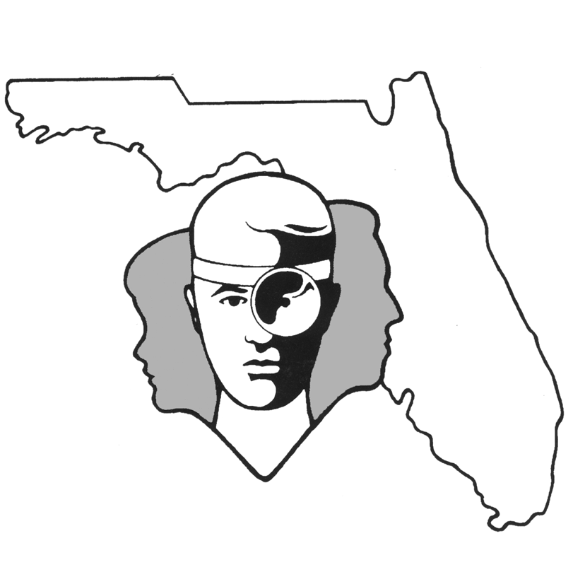
TALLAHASSEE EAR, NOSE & THROAT - HEAD & NECK SURGERY, P.A.

www.TallyENT .com Office Phone: 850-877-0101

PATIENT DISCHARGE INSTRUCTIONS:
FUNCTIONAL ENDOSCOPIC SINUS SURGERY (FESS)

POST-ANESTHETIC CONSIDERATIONS: Anesthetics and other medications will be in your body 24 hours, so you may feel a little sleepy. This feeling will slowly wear off, but for the next 24 hours, adults should not:
- Drive a car, operate machinery or power tools  Drink any alcoholic beverages
- Make any important decisions – such as signing legal documents  Take any medication except as directed
Certain anesthetics and pain medications may produce nausea & vomiting which usually resolves by the evening of the surgery.

ACTIVITY: You should avoid any kind of heavy exercise or straining for two weeks.

DIET: You should progress slowly to a regular diet as tolerated. It is better to start with liquids such as Ginger Ale or apple juice, then soup and crackers, and gradually advance to solid foods.

WOUND CARE: You may take a shower or bath as desired. You may change nasal tip dressing as needed and as demonstrated. If there is no drainage, you may remove the dressing. You may expect bloody nasal secretions postoperatively. Do not blow your nose! If you feel like you are going to sneeze, please try to do it with your mouth open. Also, it is best if you can keep your head elevated. A day after surgery, you should start irrigations as instructed by your surgeon. (available over the counter kits: NEIL-MED, Neti Pot or Simply Saline). Do this two to three times a day for until you return for your postoperative appointment. Saline spray (Ocean, Ayr) can be used more frequently as instructed by your surgeon.
MEDICATIONS: You should have a medication for pain and may also be given an antibiotic. Be sure to take the antibiotic as prescribed and for the full time recommended by your surgeon. If you do not have these, please ask your surgeon about them to make certain. Unless otherwise indicated, you may try taking an antihistamine-decongestant, which might help with nasal congestion. You may try using a topical nasal decongestant (such as Afrin or Duration). You can continue this for three to five days postoperatively. Obviously, in the circumstances of complete nasal packing, this will make no difference. You Can use Tylenol, ibuprofen, naproxen or any pain medication prescribed by your surgeon for pain relief. DO NOT take Tylenol and your prescribed pain medicine together.

SYMPTOMS TO EXPECT: You can expect moderate discomfort the first night and congestion for the first week. You can expect red (bloody) fluid-type drainage from your nose with some postnasal drainage with this as well. In general, it should gradually decrease over the first couple of days.
WHEN TO CALL YOUR PHYSICIAN:
- If you have brisk bleeding (a fast drip-drip), have purulent (pus-like) drainage, expel clots, and/or
begin to swallow blood
- If you have a temperature of more than 101.5 degrees at any point
- Pain uncontrolled by the prescribed medications
- If nausea becomes a problem
- If bruising occurs around the eyes or swelling/bruising of the upper lip

SPECIAL INSTRUCTIONS: A postoperative appointment has already been scheduled. Please refer to your Surgery Information Sheet or call the office to confirm the appointment date and time. We strongly suggest that a responsible adult be with the surgical patient the rest of the day and also during the night for the surgical patient's protection and safety. Please contact your physician immediately if any emergent problems occur. If you find that you cannot contact them, but feel that your signs and symptoms warrant a physician's attention, go to the nearest emergency room. For non-emergent questions (i.e. appointments or general questions), please call during normal office hours.

